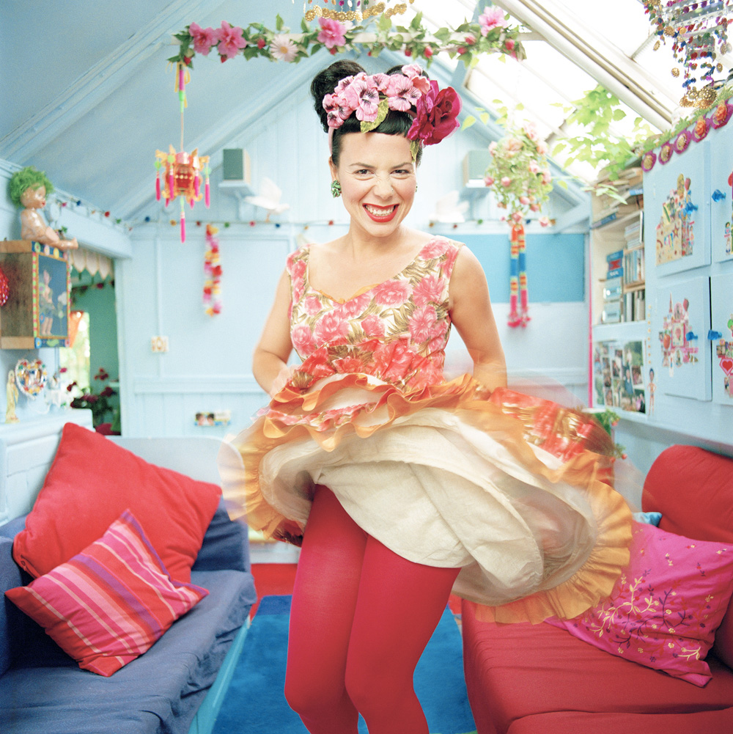

I have 20 years experience designing costumes for film, television, commercials and theatre.

Languages: English, Portuguese and Spanish

Feature Films Director

Inbetweeners Ben Wheeler with Bwark productions
Cuban Fury James Griffith with Big Talk
Attack The Block Joe Cornish with Big Talk
Sightseers Ben Wheatley with Big Talk
In Fear Jeremy Lovering with Big Talk
Gone Ringan Ledwige with Big Talk
Dogma 95 – The King is Alive Christian Levering
Happy Now Phillipa Cousins

Television Films Director Production Company

The Royal Wedding James Griffith Channel 4
Hancock and Joan Richard Laxton BBC 4
Daphne Claire Beaver BBC 4
Churchill Lucy Carter BBC2

Television Programmes/sitcoms Director Production Company

Freeagents (sitcom) James Griffith Channel 4
Bad Sugar (sitcom PILOT) Ben Wheeler Tiger Aspect
Queen of Sheba (docu drama) Alex Dunlop Atlantis Productions
Ceremonies in Egypt (docu drama) Robert Morgan BBC Wales
Cinderella (comedy) John Henderson Channel 4
Jack and the Beanstalk (comedy) John Henderson Channel 4

Theatre Director Production Company

The Magic Flute Christopher Newell Welsh National Opera
The Bartered Bride Christopher Newell Welsh National Opera
The Marriage of Figaro Christopher Newell Welsh National Opera
Yarico Musical Jamie Heinz Holders Season Barbados

Below is a list of some of the commercials that I have worked on.
A full list can be supplied on request.

Director Production Company Product

Ringan Ledwig Harry Nash John Long Silver
Super Noodle
Green & Blacks
Quiznos
Small Family Business Coca Cola
Lynx
Addidas
Rattling Stick Stella Artois
Vodaphone
John Lewis
Stella Artois
The 3 pigs - Guardian

Ivan Bird Rattling Stick Sky

Brian Lee Hughes Stink Cadbury’s egg&spoon
Mentos

Ian Bonhote Pulse Tena

Niall Downing Partizan Pokerstars
Sainsbury’s spiceworld
( I won the BTAA award for this )

Knorr
Asda

James Griffith Moxie Films 1960’s Patak
Majestic
Ladbrokes

Jim Hoskins Partizan 118 118 Campaign
Lucozade
Hula Hoops
Freeserve
Match.com
Mini Cooper
Nutragrain
Cadbury Mini Rolls Happydent
Stink Rembrandt

Traktor Partizan Aquafina
Bacardi

Eric Lynne Partizan Abbey National
Surf

Andy Lambert Partizan Abbey National Halifax
Blink The Samaritans

Neil Harris Stink Eve Magazine
Heinz

Theo Delaney Tomboy Films McDonalds

Happy Arden Sutherland & Dodd’s Fray Bentos
Nike

Super Noodle

Jackie Oudney Bliss BBC Opera
British Gas
Warburton’s
N-Power
McDonalds
Warburton

Graeme Linehan Talk Back Kit Kat
Ikea Campaign

Richard Avoade Moxie Films Citroen

Jared Hess Moxie Films The Range

Mat Kirkby RSA films KFC

